Jonathan Turner Board Member Report
6th March 2020 – 7th May 2020
As I began this report, we had a full calendar of engagements booked to consult with our communities on the Local Board plan and the Annual Budget. However, with the onset of Covid-19 and the effect it has had on Aotearoa many things have changed. We have shifted our meetings to be online and the majority of my work has been via email and phone. I have also been participating in a range of webinars relevant to my role with a focus on sustainability and improving transport. A big task for me over the last month was putting together the board’s submission on the Government’s Accessible Streets law reform package.
My thanks go out to our community who have pulled together and worked hard to eradicate Coronavirus from our shores and I look forward to getting out amongst you all soon.

Roles assigned by the local board
- Transport portfolio secondary.
- Appointed to the Manukau Harbour Forum.

General / assigned roles update
- Logged a variety of issues with council including:
  - Weeds in walkways between streets
  - Leak on Richardson Rd
  - Traffic light issues in Mt Roskill shops
  - Traffic light phasing issues at Maioro Street/SH20.
  - Disused bus stop on Alex Boyd Link lacking signage indicating this.
  - A number of footpath issues.
  - A range of issues on Winstone Road. AT have indicated they will be looking at fixing the pedestrian crossing in a reasonable amount of time.

- Communicated with residents about a number of concerns:
  - Carlton Street upgrade concerns – residents worried that the bus route will not be put in place. BECA presented their safety audit of Carlton Street and confirmed that ‘minor’ risks currently exist and will not be exacerbated. We are now waiting for the next steps.
  - Commodore/Hillsborough/Margaret Griffin intersection – issues around parking and sightlines.
  - Safety of cycleways – witnessed an accident on the turnoff from the SW cycleway. I have proposed that a protected ramp onto the road be added here.
  - Weeds in a number of walkways. These have been reported to Auckland Council and will be dealt with.
  - Advocated for keeping the eastern interior gate of Hillsborough Cemetery locked after multiple reports of illegal activities and unwanted parties.
  - Communicated with members of the Epidemic Response Committee about clarifying the rules around bicycle shops and essential repairs under Level 4.
  - Pest plants such as Australian Wattle in the Hillsborough Cemetery/Belfast Reserve forest. Waiting to hear more from the parks team on this.
  - Residents wanting to allocate more of the road carriageway to pedestrians and cyclists in light of the Covid-19 outbreak. During the lockdown there have been more people out walking and our small footpaths have been highlighted as an area of concern. Focus areas include Hillsborough Road, Mount Roskill Shops, Stoddard Road and Littlejohn Street. At the previous business meeting I asked that pedestrian buttons be made automatic and this has occurred at a number of locations in the board area.
  - Issues around noise of resurfacing works on Dominion Road.

Meetings / events attended

- 6th March - Kura Kāwana workshop on Conflicts of Interest
- 9th March – Monthly catch up with Auckland Transport with member Fairey
- 10th March – Meeting with AT, BECA, Councillor Fletcher, member Fairey and residents of Hillsborough to discuss the safety audit of Carlton Street
- 11th March – Exhibition openings at Pah Homestead, Monte Cecilia Park.
- 12th March – Local Board Workshop
- 13th March – Kura Kāwana workshop on Obligations to Māori and co-governance.
- 16th March – Local Board Members forum
- 16th March – Agenda Run through for Business meeting
- 17th March – Met with constituent to discuss issues with roads and parks in the Hillsborough area
- 19th March – Local Board Business meeting
- 19th March Local Board workshop
- 26th March – Local Board workshop over Skype
- 26th March – Integrated Area Planning workshop with Albert-Eden members
- 2nd April – Local Board Workshop over Skype
- 3rd April – Zoom discussion with members of Albert-Eden, Whau, Waitemata and Upper Harbour local Boards about ways to approach a potential continued water crisis.
- 4th April – Met with constituent to discuss stopgap measures to allow for greater pedestiran movement during Covid-19
- 6th April – Zoom discussion with Kainga ora and residents about the innovating streets fund.
- 9th April – Local Board workshop over Skype
- 15th April – Innovating Streets Webinar hosted by NZTA
- 16th April – Local Board workshop over Skype
- 17th April - Sustainability insights and opportunities in COVID 19 landscape webinar hosted by the sustainability society
- 20th April – Auckland Transport issues catchup
- 23rd April – Local Board workshop over Skype
- 24th April – How to talk about Urban Mobility webinar hosted by NZTA
- 25th April – ANZAC day commemorations – our area embraced the “Stand at Dawn” event and many households acknowledged the day in creative ways.
- 28th April – Innovating streets discussion with NZTA about improving the pedestrian experience on Littlejohn/Carlton Street.
- 29th April – Discussion with Kainga Ora representative about Innovating streets projects in Roskill South and Waikowhai.
- 30th April - Local Board workshop over Skype.
- 30th April – Integrated Area Plan meeting with members from Albert/Eden Local Board.
- 7th May – Local Board workshop over Skype.
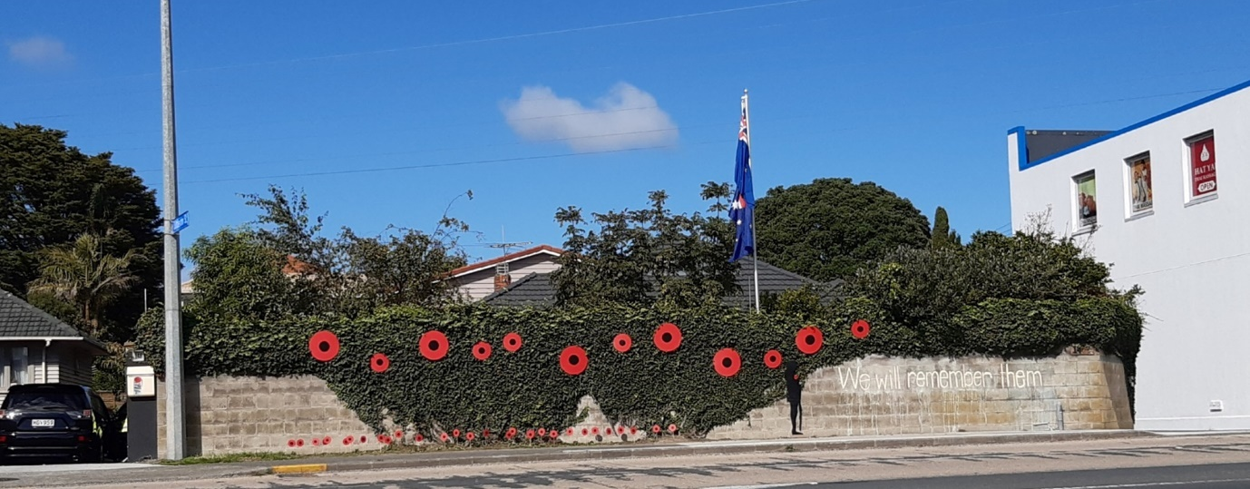
A local resident’s display for ANZAC day.

Conferences / member development
- 6th March – Attended the Kura Kāwāna session on Conflicts of Interest with members Fairey, Doig, Lai and Shen. This was an interesting session that covered the different ways members can have a conflict of interest, while emphasising that having a conflict of interest is not a “bad” thing to have.
- 13th March Kura Kawana obligations to Māori seminar
- 16th March Local Board Member’s forum – attended by a wide range of Local Board members, discussing a large range of issues.
- 15th April – Innovating Streets Webinar hosted by NZTA
- 17th April - Sustainability insights and opportunities in COVID 19 landscape webinar hosted by the sustainability society
- 23rd April – Innovating Streets second Webinar focused on FAQ hosted by NZTA
- 24th April – How to talk about Urban Mobility webinar hosted by NZTA

Disclosures

Recommendation
That this report be received.
Note: if other recommendations are proposed they may be subject to a Notice of Motion (refer to Standing Orders or Appendix 1 pg. 5-6 in the guidance document).

